**Building A Personalized Movie Recommender System**

Muhammed Adebisi

School of Computing and Mathematics

University of South Wales

A submission presented in partial fulfilment of the requirements of the University of South Wales/Prifysgol De Cymru for the degree of MSc Data Science

September, 2023

**UNIVERSITY OF SOUTH WALES**

**PRIFYSGOL DE CYMRU**

**FACULTY OF COMPUTING, ENGINEERING & SCIENCE SCHOOL OF COMPUTING & MATHEMATICS**

# STATEMENT OF ORIGINALITY

I, **MUHAMMED ADEBISI**, hereby declare that the work presented in this dissertation, titled "BUILDING A PERSONALIZED MOVIE RECOMMENDER SYSTEM” is entirely my own original work, except where explicitly indicated otherwise.

I affirm that:

1. Any external sources, whether in the form of published literature, online resources, or any other medium, have been appropriately cited and referenced throughout this dissertation.
2. Any collaborative work, contributions, or guidance received from advisors, peers, or other individuals have been duly acknowledged, and their specific contributions are clearly identified.
3. All experiments, data analyses, and findings presented in this dissertation are the result of my independent research efforts, unless otherwise stated.
4. This dissertation has not been submitted in part or in full for any other academic qualification, degree, or certification.

I understand that academic honesty and integrity are paramount, and I have adhered to the ethical guidelines and standards set forth by my academic institution.

I am fully aware of the consequences of academic misconduct and plagiarism, and I take full responsibility for ensuring the originality and authenticity of the work presented in this dissertation.

Signature: …………………………muhammedadebisi………………………………………

Date: ………………………8th September, 2023………………………………..

# ACKNOWLEDGEMENT

I would like to express my heartfelt gratitude to my parents, Mr., and Mrs. Adebisi, for their unwavering support and encouragement throughout my journey to complete my MSc dissertation. Their love, patience, and belief in me have been the driving force behind my academic achievements. Their sacrifices and endless encouragement have been instrumental in helping me reach this milestone.

I would also like to extend my sincere appreciation to my dear uncle, Assistant Professor Adebisi Jeleel, for his guidance and mentorship during this challenging endeavor. His invaluable insights, wisdom, and willingness to share his knowledge have been instrumental in shaping the direction of my research and helping me navigate the complexities of my academic pursuit.

I would like to express my heartfelt gratitude to Joel Harris for his unwavering guidance, invaluable insights, and unwavering support throughout the completion of my dissertation.

I am deeply grateful for the sacrifices and understanding that my parents and uncle have shown throughout this process. Your unwavering support has been my pillar of strength, and I could not have accomplished this without you.

# ABSTRACT

This paper contains the final report for the MSc Final Project titled “Building a Personalized Movie Recommender System Using Machine Learning Techniques.” Recommendation systems are programs created to suggest items, in this case, movies, to users based off either the user’s history or similarity in the movies. Machine learning, being a means of building software with the ability to find similarities and make predictions, has been applied in the creation of recommendation systems in recent times. The focus of this study is the creation of a recommendation system that could address the cold-start problem using an approach where a movie title is all the input needed for the system to make recommendations, using the MovieLens Dataset.

An analysis of the domain as well as a literature review were conducted, providing a summary of the theoretical and experimental background. This summary was then used to justify the methodology applied in the development of the recommendation system.

The document discusses creating a recommendation system using movie details, user ratings, and user-generated tags to suggest similar movies. It includes an interactive interface made with "ipywidgets" for user input. The system's performance is evaluated by comparing it to a title-only recommendation system, highlighting the influence of user ratings and tags on recommendations.

**TABLE OF CONTENTS**

STATEMENT OF ORIGINALITY 2

ACKNOLEDGEMENT 3

ABSTRACT 4

LIST OF FIGURES 7

LIST OF TABLES 8

CHAPTER 1: INTRODUCTION 9

1.1 BACKGROUND AND CONTEXT 9

1.2 PROBLEM STATEMENT 9

1.3 PROJECT OVERVIEW 10

1.3.1 AIMS 10

1.3.2 OBJECTIVES 10

1.3.3 PROCESS 10

1.4 REPORT STRUCTURE 11

CHAPTER 2: DOMAIN ANALYSIS 13

2.1 MOVIE RECOMMENDATIONS, DATASETS AND PERSONALIZATION 13

2.1.1 MOVIE RECOMMENDATION SYSTEMS 13

2.1.2 TYPES OF RECOMMENDATION SYSTEMS 14

2.1.3 THE MOVIELENS DATASET 15

2.2 DEEP LEARNING IN RECOMMENDATION SYSTEMS 16

2.2.1 INTRODUCTION TO DEEP LEARNING 16

2.2.2 NEURAL NETWORKS 16

2.3 PYTHON IN DATA ANALYSIS 17

2.3.1 PYTHON 17

2.3.2 PYTHON LIBRARIES FOR DATA ANALYSIS 17

2.3.3 PYTHON IN RECOMMENDATION SYSTEMS 18

CHAPTER 3: LITERATURE REVIEW 19

3.1 INTRODUCTION 19

3.2 RECOMMENDATION SYSTEMS 19

3.3 PERSONALIZATION IN MOVIE RECOMMENDATION SYSTEMS 20

3.3.1 COLLABORATIVE FILTERING TECHNIQUE 20

3.3.2 CONTENT-BASED FILTERING TECHNIQUE 21

3.3.3 HYBRID RECOMMENDATION TECHNIQUE 21

3.3.4 CHALLENGES IN PERSONALIZATION 22

3.4 MACHINE LEARNING TECHNIQUES 23

3.4.1 MATRIX FACTORIZATION 23

3.4.2 REINFORCEMENT LEARNING 23

3.4.3 DEEP LEARNING 24

3.5 EVALUATION METRICS FOR MOVIE RECOMMENDATION SYSTEMS 25

3.6 GAPS AND LIMITATIONS IN THE EXISTING RESEARCH 26

CHAPTER 4: IMPLEMENTATION 28

4.1 INTRODUCTION 28

4.2 DATA PRE-PROCESSING 28

4.2.1 DATA GATHERING 29

4.2.2 EXPLORATORY ANALYSIS 29

4.2.3 DATA CLEANING 29

4.2.4 CLEANING OF TAGS 34

4.3 TF-IDF VECTORIZATION 34

4.4 COSINE SIMILARITY AND THE SEARCH FUNCTION 35

4.5 USER INTERACTION WITH IPYTHON WIDGETS 36

4.6 COMBINED RECOMMENDATIONS FROM RATINGS AND TAGS 36

4.6.1 CALCULATING RECOMMENDATION PERCENTAGES BASED ON RATINGS 36

4.6.2 CALCULATING RECOMMENDATION PERCENTAGES BASED ON TAGS 37

4.6.3 COMBINING RECOMMENDATIONS FROM RATINGS AND TAGS 38

4.6.4 SORTING AND RETURNING RECOMMENDATIONS 38

4.7 FINAL RECOMMENDATIONS 38

CHAPTER 5: EVALUATION 40

5.1 CLEAN TITLE COLUMN CREATION 40

5.2 VECTORIZATION TEST 40

5.3 RECOMMENDATION TEST 41

5.4 USE OF RATINGS AND TAGS IN RECOMMEDATION GENERATION 42

CHAPTER 6: CONCLUSION 44

6.1 CONCLUSION 44

6.2 FUTURE WORK 45

REFERENCES 46

APPENDIX 51

# LIST OF FIGURES

Figure 1 - Plot for number of movies and ratings per year 32

Figure 2 - Distributions by genre, on top of total rating distribution. 32

Figure 3 - Cumulative number of movies, in total and per genre 32

Figure 4 - Bar chart plot for genre of movies tags 33

Figure 5 - Comparative bar plot of average and std_dev for movie ratings 33

Figure 6 - Pie chart of all genres 34

Figure 7- “Clean Title” Column Creation Test 40

Figure 8 - TF-IDF Vectorization Test 41

Figure 9 - Recommendation Percentages Test 41

Figure 10 - Recommendation List from Titles 42

Figure 11 - Recommendation List using Movie Titles, Ratings and Tags 43

Figure 12 - code implementation for movies per year 51

Figure 13 - code implementation for movies ratings histograms 51

Figure 14 - code implementation for movies per genre 52

Figure 15 - code implementation for movies ratings descriptive stats and pie chart 52

Figure 16 - code implementation for average ratings per user 53

Figure 17 - importing data and libraries 53

Figure 18 - Code for exploratory data analysis of the movies dataframe 53

Figure 19 - Importation of the re library and the clean_title function 53

Figure 20 - creating a new column and storing the cleaned tittle in the movies dataframe 54

Figure 21 - Cleaning the tags dataframe 54

Figure 22 - the codes for the TF-IDF vectorization 55

Figure 23 - search function using cosine similarity 56

Figure 24 - Widget enabling User interaction 57

Figure 25 - The find_similar_movies function 58

Figure 26 - The creation of the widget enabling the use of the recommendation system 59

# LIST OF TABLES

Table 1- A comparison of the strength and limitations of the evaluation metrics 26

# CHAPTER 1: INTRODUCTION

## 1.1 BACKGROUND AND CONTEXT

Movie recommendation systems have become significantly more important as the popularity of online streaming platforms has increased. Streaming platforms possess rich libraries of movies and TV shows, making it difficult for users of the platform to navigate through and find content that is like those they prefer (Hastie, 2019).

Movie recommendation systems are built primarily to solve this problem by making relevant and personalized movie recommendations to the user based on their preferences, past viewing history and demographics. These accurate and tailored recommendations are produced by these systems using machine learning techniques as well as advanced algorithms, the use of which not only helps users discover new movies but helps retain and satisfy users on the streaming platform (Koren, Bell and Volinsky, 2009).

The large volume of content presently available on streaming platforms is one of the reasons why movie recommendation systems are needed. Netflix, for example, offers thousands of movies and shows, which without a recommendation system, would have to be manually combed through by the user in search of other movies, resulting in time wastage and potentially being overwhelmed (Bobadilla et al., 2012).

Existing movie recommendation systems use various approaches, including collaborative filtering, content-based filtering, and hybrid methods. Collaborative filtering involves the analysis of user behavior and preferences to identify similar users and recommend movies based on a blend of their collective preferences (Sarwar et al., 2001). Content-based filtering involves the analysis of the attributes of movies themselves, such as genre, actors, and directors, to recommend similar movies to users (Pazzani & Billsus, 2007. Hybrid methods involve the combination of both collaborative and content-based filtering techniques to provide more accurate and diverse recommendations (Burke, 2002).

## 1.2 PROBLEM STATEMENT

Movie recommendation systems are faced with several challenges despite the growth in that area of technology. The cold start problem is one of the challenges that movie recommendation systems must deal with. This challenge occurs when there is insufficient data either for a new user (no viewing history or preferences) or new movie with insufficient data (attributes). Accurate recommendations are difficult to make in this case. The sparsity problem which is little interactions between users and the movies on the platforms making pattern identification and therefore accurate recommendations almost impossible (Schein *et al*., 2002;Koren, Bell and Volinsky, 2009).

This project aims to build a movie recommendation system that solves the cold start problem and the sparsity by allowing the user to input the name of any movie they have watched and enjoyed. The system would then generate recommendations for the user.

## 1.3 PROJECT OVERVIEW

### 1.3.1 AIMS

This project aims to develop a movie recommendation system using machine learning techniques and advanced algorithms which will overcome these challenges. The research aims to study and incorporate deep learning and matrix factorization into the design of the system to enable it to capture the dynamic nature of user preferences.

### 1.3.2 OBJECTIVES

This project has as its primary objective the development of a movie recommendation system using Python and machine learning techniques. This recommendation system will be built using the MovieLens Dataset and will apply machine learning algorithms to generate personalized recommendations of movies. Ratings, movie details and tags will be used to create this system and ensure its accuracy.

The objectives also include:

1. Utilization of collaborative filtering and content-based filtering techniques
2. Evaluation and comparison of different machine learning algorithms.
3. Preprocessing and analysis of the MovieLens Dataset.
4. Design and implementation of a website with user-friendly interface to enable users to interact with the recommendation system.
5. Evaluation of the recommendation system’s performance.

### 1.3.3 PROCESS

The execution of this project will be done systematically. The steps involved will be broken down in this section.

Firstly, the MovieLens Dataset will be downloaded and preprocessed to make the data ready for training the model as well as evaluating it. The preprocessing techniques conducted will ensure that there are no missing values, that the data is normalized and of the required quality for the development of the system.

Having prepared the data, the focus will move to the design and architecture of the recommendation system. The system will be built in modules, each handling specific tasks such as data processing, feature extraction, and recommendation generation. The system workflow will be defined to outline the sequence of operations and interactions between the modules.

Then, the implementation phase will begin. This will involve the selection and training of the machine learning models for the recommendation system. Algorithms such as matrix factorization, neural networks and ensemble methods will be explored to evaluate their effect on the recommendation system’s performance in generating relevant and accurate recommendations. The model(s) built will then be trained using the preprocessed data, and appropriate evaluation metrics will be employed to evaluate their performance.

The project will also focus on the user interface design and implementation. A user-friendly website will be developed to allow users to interact with the recommendation system easily. The interface will provide options for users to input their preferences (a movie they enjoyed watching) and receive recommendations on similar movies.

The effectiveness of the recommendations will be evaluated using the experimental results as well as the feedback from the users who will be given a form to fill in their feedback and evaluation of the system after interacting with it. Performance evaluation metrics such as precision, recall, and mean average precision will also be used to assess the accuracy and relevance of the recommendations. Users’ satisfaction will also be considered as a significant measure of the system’s effectiveness.

## 1.4 REPORT STRUCTURE

This report is divided into 6 chapters. The first chapter “Introduction” contains the background and motivation for embarking on this project, the problem the project set out to solve and the process by which the solution which is the movie recommendation system is to be developed.

The second chapter “Domain Analysis” explains the basic ideas and concepts of movie recommendation to aid the understanding of this project; discusses personalization and presents the MovieLens dataset.

The third chapter ‘Literature Review” contains the exploration and examination of the present literature on the development of movie recommendation systems, the utilization of machine learning and its different techniques, and the evaluation of present recommendation systems. The summary of this chapter will contain any gaps observed in the literature as well as pointers that will affect the design of the recommendation system in this project.

The fourth chapter “Design and Implementation” contains the description of the design and the building of the model and follows the whole implementation process.

The fifth chapter “Evaluation” provides and interprets the results of the experimental process as well as the feedback gotten from the users who have interacted with the system via the website. The system will also be compared to the project requirements and objectives via the results obtained. A section considering any professional, legal, social, or ethical issues will be included here.

The final chapter “Conclusions” draws the conclusions of this research report by providing a summary of its content and by discussing some final considerations related to limitations and future improvements.

# CHAPTER 2: DOMAIN ANALYSIS



## 2.1 MOVIE RECOMMENDATIONS, DATASETS AND PERSONALIZATION

The aims for this section are to explain the basic ideas and concepts of movie recommendation to aid the understanding of this project; discuss personalization and present the MovieLens dataset.

### 2.1.1 MOVIE RECOMMENDATION SYSTEMS

A recommendation system is a system that uses data from the user to make recommendations of relevant content to the user (Falk, 2019). Movie recommendations are algorithms used to make movie suggestions to users based on their preferences and viewing history. The aim of these systems is to make recommendations which are personalized to suit the interests of the user to improve the movie-watching experience (Burke, 2007). To gain better understanding of movie recommendation systems, a few basic concepts need to be understood.

1. Item Representation:

Item representation refers to the various attributes used to represent movies. These attributes include genre, director, release year and actors. These attributes help in forming a basis for the recommendation algorithms for the identification of movie similarities and differences.

1. Ratings:

For movie recommendation systems to function optimally, user ratings must be included in the systems as they provide direct information on the user’s opinion of the movie. It also provides insight into the preferences and taste of the user and helps to make the recommendation system more accurate. This information is useful in the training of recommendation models (Ricci, Rokach and Shapira, 2022).

1. User Preferences:

Understanding the preference of a user is essential to the effectiveness of a recommendation system. This is done by collecting and analyzing data such as previous movie ratings, movie history, reviews, and feedback. This can be used to identify user patterns and make recommendations to the user.

1. Cold Start Problem:

The cold start problem is the challenge of providing valuable recommendations despite having only a little data to create the recommendations. Recommender systems are highly dependent on user preference and item attributes, and so, the lower the amount of such data available, the lower the accuracy of the system tends to be.

### 2.1.2 TYPES OF RECOMMENDATION SYSTEMS

There are three main types of recommendation systems: collaborative filtering; content-based filtering and hybrid systems (Burke, 2002). The collaborative filtering systems make their recommendations using the ratings of users who have similar preferences to the user. They are based on the principle that if two users have had similar preferences or ratings of a movie previously, they are likely to have the same ratings for movie later. Collaborative filtering recommendations are made based on the similarity of the users’ preferences (Sarwar et al., 2001).

Content-based filtering systems make recommendations based strictly on the user’s preferences in the past by selecting movies which are similar. It relies heavily on item representation and uses the movie attributes to identify similar movies. They operate on the principle that if a user has shown a positive reception to a movie in the past, they would enjoy a movie with similar features (Pazzani & Billsus, 2007).

Hybrid systems combine both approaches, using their strengths and overcoming their weaknesses to make their recommendations. The combination of the strengths of these approaches helps to make the recommendations more accurate (Burke, 2002). This combination to produce hybrid systems can be done in different ways such as the mixed, cascade, feature combination, weighted and switching methods (Burke, 2002).

A mixed method involves the generation of recommendations separately by each approach and then presenting them as one recommendation list. A cascade method involves the use of one approach to refine the recommendations generated from the other approach. The feature combination method involves the combination of the selection features of both models into one recommendation system. A weighted method involves the combination of the recommendations from both approaches into a single score using a weighted average.

Movie recommendation systems have been integrated into online movie platforms such as Hulu, Netflix and Amazon Prime, and have had an impact on user experience and engagement with these platforms (Gomez-Uribe & Hunt, 2019). Netflix uses a hybrid recommendation system which uses collaborative filtering to find similar users while using content-based filtering to find similar movies. These are then combined to generate personalized recommendations to users.

### 2.1.3 THE MOVIELENS DATASET

The MovieLens dataset is a collection of movie ratings which is compiled by the University of Minnesota’s GroupLens Research Project team. This is a dataset that is widely used for research and development, movie analysis and recommendation systems. The dataset structure is made up of multiple files containing different information on the movies and viewer ratings. It contains 6 files which are tags.csv, movies.csv, ratings.csv, links.csv, genome-tags.csv and genome-scores.csv. The files in the dataset are written as comma-separated values with a single header row and are encoded in UTF-8.

The tags.csv file contains user-generated tags for the movies. It contains the following columns: ‘userid’ which is an integer used to represent the users; ‘movieid’ which is an integer used to represent the movies; ‘tag’ contains the tag itself as entered by the user; and ‘timestamp’ contains the time at which the tag was entered, and is calculated by the number of seconds since the midnight (UTC) of January 1, 1970 (Harper & Konstan, 2016). Each row in the file represents a different tag entered by a user to a movie.

The movies.csv file contains movie information. It contains the following columns: ‘movieid’ which contains the integer identifier for that movie; ‘title’ which contains the movie’s title and the release year in brackets; and ‘genres’ which contains a list of genres associated with the movie. The associated genre(s) are selected from a list of 18 pre-defined genres which are Action, Adventure, Animation, Children, Comedy, Crime, Documentary, Drama, Fantasy, Film-Noir, Horror, Musical, Mystery, Romance, Sci-Fi, Thriller, War, and Western. Each row in the file represents a different movie in the dataset.

The ratings.csv file is the central file of the dataset containing over 25 million ratings from about 160 thousand users for about 62,000 movies. The columns are ‘userid’ and ‘movieid’ which are identifiers for the users and movies respectively; ‘timestamp’ which contains the time of rating in the same format as detailed earlier; and the ‘rating’ column which contains the movie’s rating as entered by the user on a pre-determined scale from 0.5 to 5 stars. Each row represents a different rating given to a movie by a user.

The links.csv file contains identifiers which are used to link the movies in the dataset to other sources such as the IMDb (Internet Movie Database) and TMDb (The Movie Database). The genome-scores.csv contains relevance scores for the tags associated with the movies while the genome=tags.csv contains tag descriptions for the tags used in the genome file.

## 2.2 DEEP LEARNING IN RECOMMENDATION SYSTEMS

Deep learning is a subsection of Machine learning which is used in the building of recommendation systems as well as other domains. This section contains an exploration of the use of deep learning in the execution of this project.

### 2.2.1 INTRODUCTION TO DEEP LEARNING

Deep learning is a form of machine learning which focuses on training artificial neural networks with multiple layers of data to learn complex relationships and patterns. All machine learning systems aim to learn a mathematical representation of data that effectively explains the data relationship with output. Having learned this mathematical representation, it can then be applied to new input to generate answers even without known rules. However, different machine learning systems employ different representations and learning methods.

Deep learning stands out from the other via layered representation (Chollet, 2017). Deep learning models are made up of multiple layers that perform mathematical operations. Its ability to extract features and details from raw data removes the need for manual engineering of those features, has made it an extremely popular technique (LeCun, Bengio and Hinton, 2015). When applied in recommendation systems, deep learning can increase the accuracy of the system as it captures complex user-movie interactions and provides more accurate recommendations.

### 2.2.2 NEURAL NETWORKS

Neural networks are machine language models whose design are inspired by the structure and functionality of the human brain (Goodfellow et al., 2016). They are made up of organized layers of neurons, which are interconnected nodes. The layer which receives the initial data is called the input layer, the computations are conducted by the other ‘hidden’ layers and the output layers produce the predictions of the model.

The computations conducted by deep learning models are done using activation functions (Nielsen, 2015) Activation function create non-linearities in the system, making it possible for the system to identify and model complex relationships. These functions include the rectified linear unit (ReLU) function and the sigmoid function.

The strength of the connections between neurons in a neural network are determined by the weights while the biases introduce extra parameters. Regularization techniques, such as dropout and L1/L2 regularization, are crucial in neural architectures to prevent overfitting (Goodfellow et al., 2016). These techniques introduce penalties or constraints on weights, encouraging the network to learn more generalizable patterns.

The learning algorithm used to train the neural network is another important element. Backpropagation is a popular algorithm that calculates the gradient of the loss function with respect to the weights and biases (Nielsen, 2015). Optimization algorithms like stochastic gradient descent (SGD) and Adam are commonly used to efficiently update the parameters during training.

## 2.3 PYTHON IN DATA ANALYSIS

### 2.3.1 PYTHON

Python is one of the most used programming languages in the field of data analysis. This is due to the simplicity of its syntax, versatility, and the large number of libraries it possesses (McKinney, 2012). It is an open-source, high-level language that supports multiple programming paradigms, including procedural, object-oriented, and functional programming. Python has an intuitive syntax, making it easier for beginners to learn and experienced programmers alike (Pérez & Granger, 2007).

### 2.3.2 PYTHON LIBRARIES FOR DATA ANALYSIS

Python’s use in data analysis is powered by the extensive library suite. Pandas, Seaborn, NumPy and Matplotlib are essential tools for data analysis (VanderPlas, 2016) as Pandas offers data structures, file interactions and operations for manipulating tables, numeric data and even time-series data; Seaborn provides tools for visualizing the data; Numpy provides the essential support needed for arrays, matrices and numerical computations; and MatPlotlib is a plotting library that produces quality figures in a variety of formats, which can be used in Python scripts, shell, web application servers, and other graphical user interface toolkits (Hunter, 2007).

Python also provides libraries such as SciPy for scientific computing, Scikit-learn for machine learning, and Statsmodels for statistical modeling (Pedregosa et al., 2011; Seabold & Perktold, 2010). These libraries provide efficient and user-friendly interfaces for tasks such as regression, clustering, and dimensionality reduction. Due to its versatility, Python is also used in big data applications. Libraries such as PySpark and Dask allow for distributed computing, enabling the analysis of large datasets that do not fit into memory (Zaharia et al., 2012; Rocklin, 2015).

### 2.3.3 PYTHON IN RECOMMENDATION SYSTEMS

Two Python libraries have gained prominence in the development of recommendation systems: Surprise and Implicit. Surprise is a Python scikit that provides simple yet powerful algorithms for collaborative filtering, a common technique in recommendation systems (Hug, 2017). It offers various prediction algorithms such as KNN, SVD, and matrix factorization, and tools for model evaluation, selection, and tuning.

Implicit is a library designed for implicit feedback datasets, which occur more frequently in real-world scenarios. It provides fast Python implementations of several popular algorithms, including Alternating Least Squares (ALS) and Bayesian Personalized Ranking (BPR) (Benfred, 2018).

Python's capabilities are not limited to collaborative filtering. Its machine learning libraries, such as Scikit-learn and TensorFlow, can be used to implement content-based and hybrid recommendation systems. These libraries provide a wide range of machine learning algorithms and deep learning models, respectively, that can be used to extract features and predict user preferences (Pedregosa et al., 2011; Abadi et al., 2016).

# CHAPTER 3: LITERATURE REVIEW

## 3.1 INTRODUCTION

This literature review chapter contains a dive into the existing body of knowledge surrounding personalized movie recommendation systems, examining the strengths, weaknesses, and gaps in the existing research and literature. The primary focus of this literature review is the conduction of critical analysis and synthesis of the existing literature on areas such as the content-based, collaborative filtering and hybrid approaches to building recommendation system. This examination of their strengths and weaknesses will provide insights into the effectiveness of the approach in the generation of relevant recommendations.

This chapter also contains an evaluation of the concept of personalization in movie recommendation systems. Using existing literature, the benefits of personalized recommendations for users such as improved user experience and movie discover will be explored, as well as the limitations and challenges of personalization such as user privacy and the occurrence of filter bubbles which limit diversification in the content a user is exposed to.

Machine learning techniques are essential in the development of personalized movie recommendation systems and as such, a review of the existing research on the use of machine learning algorithms such as matrix factorization, reinforcement learning and deep learning, is conducted in this chapter, highlighting their strength and weaknesses in improving the accuracy of the generated recommendations and the limitations of the traditional approaches. A comparative analysis of the more frequently used evaluation metrics is also conducted in this chapter, reviewing metrics such as precision, recall and mean average precision and their suitability for the evaluation of personalized movie recommendation systems.

Gaps and limitations in the existing research are identified in this literature review with the hope of discovering research opportunities and directions for further investigations in this field. The knowledge gathered in this chapter will aid in the development of the methodology for the system built in the project as well as other more accurate and effective personalized movie recommendation systems.

## 3.2 RECOMMENDATION SYSTEMS

Recommendation systems are systems whose function is to analyze the available information using the patterns of the users and generate recommendations using the information (Alyari and Jafari, 2018). They make the search process of a platform more effective as they try to recommend the most suitable items to the user, even with little information. Recommendation systems combine various factors to find the correlations in patterns and user attributes to generate the best suggestion of products to the customers (Kumar et al., 2015).

The rapid explosion of information thanks to the internet has made it necessary to create technologies which filter the data and direct users to only suitable and relevant information (Bianchini et al.,2017; Fouladi and Jafari, 2017). The idea of recommendation systems emanated in the mid-90s as a means of offering a user interesting items using his profile information (Ortega et al., 2013). Over the last few decades, there have been several recommendation systems developed using a variety of approaches.

Though mostly used in the field of e-commerce where they suggest products and services to users based on the information entered by the user, recommendation systems are also used in several other fields including job search platforms and music recommendation platforms. An example is seen in Lawrence et al.’s recommendation system designed in 2001 to help shoppers find new products using their purchase history on the platform. In the world of movies, recommendations systems have helped users find movies which are suitable for them amidst the large amount of information present online (Deldjoo et al., 2016).

## 3.3 PERSONALIZATION IN MOVIE RECOMMENDATION SYSTEMS

To give personalized recommendations to specific users based on their interests, actions, and characteristics, personalization is essential to recommendation systems. Adomavicius and Tuzhilin (2005) conclude that personalization is essential in recommendations as it allows for the generation of relevant recommendations which enhances user satisfaction and engagement and effectiveness of the system.

Alyari and Jafari (2018) state that personalized recommendation systems are built using 5 main techniques. The most efficient and popularly used three techniques are:

### 3.3.1 COLLABORATIVE FILTERING TECHNIQUE

The first one is the collaborative filtering technique which is one of the most popular recommendation techniques used especially in e-commerce (Burke, 2002; Huang et al., 2007). This technique involves the creation of a user-item rating matrix based on the ratings of similar users with similar interests and preferences (Bobadilla et al., 2012, Ghazarian and Nematbakhsh, 2014). This technique is dependent on the relationships among the items and the correlations among the users to draw new hidden, interesting relationships between the items and the users (Safran and Che, 2016). It makes predictions of the likelihood of being interested in a particular item, given information about the user as well as other users’ purchasing history (Getoor and Sahami, 1999).

The strength of the collaborative filtering technique lies in its flexibility and ability to run independent of any machine-readable representation of the recommended items (Li et al., 2013). However, this technique has been found to have some weaknesses. It suffers from the cold start problem and is unable to manage new users and new items properly (Sun et al., 2015). It also has the rating sparsity problem especially in exceptionally large databases as it fails to find a pattern or similar users to aid in its recommendation (Rana and Jain, 2014).

### 3.3.2 CONTENT-BASED FILTERING TECHNIQUE

The content-based filtering technique functions by analyzing the products which the said user has given a rating for and recommending products which are like those (Mirzadeh and Ricci, 2007). To do this, a user profile is generated using the navigation history as well as responses to certain questions. It differs from the collaborative technique as it recommends using the similarity of the products as opposed to the similarity of the users. This focus on similarity of products limits the possibility of new products being recommended and limits the user’s experience to a particular kind of item (Montaner et al., 2003).

The strength of this technique lies in the similarity of the recommendations to the user’s history, ensuring that the recommendations are of particular interest to the user. It also solves the cold-start problem and makes it easier to manage newly added items. However, the shortcomings of this technique include the inability to evaluate an item outside the user’s preference, inability to provide recommendations to a new user, failure to offer serendipitous suggestions and a total dependence on the use of proper keywords to describe an item.

### 3.3.3 HYBRID RECOMMENDATION TECHNIQUE

Martinez et al. describe the hybrid technique as a technique that aims to solve the challenges of the other techniques by combining their strengths to make better recommendations (Martinez et al., 2008). Burke (2007) gives an example of this: One approach to address the cold-start problem in recommendation systems is to combine a collaborative filtering technique with a content-based system. In this hybrid approach, the content-based component can provide recommendations to new users who have small profiles and lack sufficient data for collaborative filtering. The collaborative component, on the other hand, can leverage statistical techniques to find similar users and generate personalized recommendations based on their preferences. By combining these two approaches, the system can overcome the limitations of each method and provide accurate and diverse recommendations to both new and existing users.

Rana and Jain (2014) point out however, that the design of hybrid technique recommendation systems needs utmost carefulness to ensure that the weaknesses of the approaches are not inherited into the hybrid. Kim and Kim (2014) also agree while stating that the performance of the hybrid technique is significantly better than the performance of each technique on its own. While concurring with the conclusion that hybrid systems are better, Burke (2002) identified seven different approaches to implementing the hybrid technique (weighted, switching, mixed, feature combination, feature augmentation, cascade, and meta-level).

The strength of the hybrid technique is that it overcomes the individual weakness of the other systems. Its main weakness, however, is in the complexity and high cost of building a hybrid system (Komkhao et al., 2013).

The other two techniques are Demographic filtering and Knowledge-based recommendation techniques.

### 3.3.4 CHALLENGES IN PERSONALIZATION

The implementation of personalization in recommendation systems is not without its challenges. The 3 main challenges that must be dealt with in the development of a personalized recommendation system are

1. Data Sparsity: Personalization requires having a lot of data on the user for whom the recommendation is being made. This amount is not always available to the system. This makes it difficult to accurately capture user preferences and generate personalized recommendations (Koren et al., 2009).
2. Privacy and Trust: Personalization in recommendation systems often requires the collection and analysis of user data. This raises concerns about user privacy and trust as the data being gathered can be used for malicious purposes also. It is therefore essential to garner user trust to ensure user acceptance and adoption of personalized recommendations (Abbas et al., 2014).
3. Cold Start Problem: When dealing with new users or new items for which there is almost no data at all, personalization is difficult to implement. Overcoming this challenge requires the use of techniques such as content-based filtering or hybrid approaches (Schein et al., 2002).

## 3.4 MACHINE LEARNING TECHNIQUES

Several machine learning techniques are employed in the building of movie recommendation systems. They are essential tools for improving the accuracy and personalization of the systems. This review examines the current research on machine learning techniques in movie recommendation systems, analyzing the algorithms and identifying their strengths and weaknesses.

### 3.4.1 MATRIX FACTORIZATION

Matrix factorization is a technique which uses vectors of factors inferred from the item rating patterns to represent both the items and the users in a recommendations system (Koren et al., 2009). Using latent factors, Matrix factorization provides a solution to the issues of sparsity and scalability which recommendation systems are often faced with. Koren et al. (2009) introduced matrix factorization in recommendation systems, showing how effective it is in making recommendation systems even more accurate. The matrix factorization was applied to the Netflix Price Dataset and its recommendation was significantly more accurate than the systems built using traditional methods.

Advances have been made in matrix factorization leading to further techniques such as the Singular Value Decomposition (Lentilucci, 2003), Probabilistic Matrix Factorization (Salakhutdinov and Mnih, 2008) and the Non-negative Matrix Factorization (Lee and Seung, 2000). Rendle et al. (2012) proposed the creation of Factorization Machines which would combine matrix factorization and feature engineering in a form that improves the capturing of complex user-item interactions. This approach has been applied to several e-commerce platforms showing its effectiveness in improving recommendations and user satisfaction.

### 3.4.2 REINFORCEMENT LEARNING

Reinforcement learning is a technique which is concerned with how the system ought to make choices in a direction that maximizes the notion of benefits and effectiveness. While widely applied, its use in recommendation systems was studied by Chen et al. (2021) emphasizing its potential to resolve the cold-start challenge, produce diverse and relevant recommendations as well as capture dynamic user preferences.

Wang et al. (2018) proposed a Collaborative Deep Learning framework which combines collaborative filtering and deep reinforcement learning to address the challenge of trading off exploration for exploitation which they identified as one of the biggest challenges of reinforcement learning. Li et al. (2019) introduced Reinforcement Learning to Rank (RL2R), a reinforcement learning approach for recommendation systems. RL2R is designed to use user feedback to train a ranking policy, considering both user satisfaction and long-term utility. By adapting and learning from user interactions, RL2R improves recommendation quality, leading to more personalized and engaging recommendations. This was done to tackle the challenge of reinforcement learning systems not being able to manage user feedback. This framework uses the strengths of both techniques to capture user preferences and item similarities, making its recommendations more accurate.

There are still some challenges faced by reinforcement learning recommendation systems. These include better accuracy in making diverse recommendations while still satisfying the user, the handling of the large amount of data needed to train the system and the computational costs.

### 3.4.3 DEEP LEARNING

The deep learning technique involves the identification and extraction of complex patterns and representations from large-scale data. Deep learning models have been widely adopted in the development of recommendation systems as they can capture complex relationships and learn hierarchical representations. He et al. (2017) proposed the Neural Collaborative Filtering model, which combines matrix factorization and neural networks to capture both latent factors and non-linear interactions between users and items. The experiments conducted showed that this model made significantly more accurate recommendations than traditional collaborative filtering methods.

Recurrent Neural Network (RNN) is another popular deep learning technique in recommendation systems whose strength is the capturing of sequential patterns in user behavior data, like click sequences or browsing history. Hidasi et al. (2015) proposed the GRU4Rec model, which utilizes Gated Recurrent Units (GRUs) to model user sessions and provide personalized recommendations. GRU4Rec has demonstrated favorable outcomes in session-based recommendation scenarios.

## 3.5 EVALUATION METRICS FOR MOVIE RECOMMENDATION SYSTEMS

The metrics used in evaluating the movie recommendation systems are important as they provide a basis for measuring techniques and their effect on the relevance and accuracy of recommendations. These include:

1. **Precision**: This measures the proportion of correctly recommended relevant items out of all recommended items. In the context of movie recommender systems, precision indicates how accurately the system suggests movies that align with the user's preferences. Higher precision implies that the recommendations are more relevant and aligned with the user's interests. However, precision does not consider the number of relevant items missed by the system, leading to a potential limitation in assessing recommendation diversity.
2. **Recall:** This measures the proportion of correctly recommended relevant items out of all relevant items in the dataset. It reflects the system's ability to retrieve all relevant movies for a user, ensuring that no relevant items are missed. Higher recall implies that the system can successfully retrieve a larger proportion of relevant movies. However, recall does not account for irrelevant items that may be recommended, potentially affecting the quality of recommendations.
3. **Mean Average Precision (MAP):** This is a metric that combines both precision and recall. It calculates the average precision at each relevant item's position in the recommendation list and then computes the meaning across all users. MAP provides a comprehensive assessment of the recommendation quality, considering both the relevance and ranking of recommended movies. However, MAP does not account for the order of items within the same rank, potentially overlooking variations in user preferences.
4. **Normalized Discounted Cumulative Gain (NDCG):** This is a metric for evaluating the quality of the recommendation list by considering both the relevance and ranking of items. It assigns higher scores to relevant items at the top of the list, considering the position of each relevant item. NDCG addresses the limitations of MAP by emphasizing the importance of item ranking in the recommendation process. However, NDCG does not consider the diversity and novelty of recommendations, potentially limiting its ability to capture the overall recommendation quality.

|  |  |  |
| --- | --- | --- |
| **EVALUATION METRIC** | **STRENGTHS** | **LIMITATIONS** |
| Precision | Simple and intuitive measure of recommendation relevance | Does not consider recommendation diversity, leading to focused recommendations |
| Recall | Reflects the system's ability to retrieve all relevant items | May overlook the quality of recommendations by not penalizing irrelevant items |
| Mean Average Precision | Combines precision and recall for comprehensive evaluation | Overlooks variations in user preferences within the same rank |
| Normalized DCG (NDCG) | Considers both relevance and ranking for nuanced assessment | Does not explicitly capture recommendation diversity and novelty |

Table 1- A comparison of the strength and limitations of the evaluation metrics

## 3.6 GAPS AND LIMITATIONS IN THE EXISTING RESEARCH

One of the prominent gaps in research on personalized movie recommender systems is the cold-start problem, where new users or items have limited data, leading to inaccurate recommendations. Current approaches often struggle to address this issue effectively. One potential solution is incorporating external knowledge sources, such as movie metadata or user profiles, to enhance recommendation accuracy for new users or items.

Another important aspect to consider is the evaluation of user satisfaction, preferences, and trust in the recommendations. While accuracy metrics like precision and recall are commonly used, they may not capture the subjective aspects of user experience. Therefore, incorporating user feedback and interaction with the recommender system is crucial for improving the performance of personalized movie recommender systems.

Also, future research should focus on understanding and utilizing contextual factors effectively. The impact of contextual information, such as time, location, and social context, on movie preferences and recommendations is an area that requires further exploration. Incorporating contextual information can help address the cold-start problem and provide more relevant and timely recommendations to users.

The identified gaps and limitations in existing research have important implications for future investigations. To begin with, researchers should prioritize addressing the cold-start problem, as it significantly affects the accuracy and effectiveness of recommendations for new users and items. To mitigate this limitation, innovative techniques that leverage contextual information, external knowledge sources, or hybrid approaches should be developed.

Secondly, it is crucial for researchers to focus on providing diverse and balanced recommendations by incorporating long-tail movies. This can be achieved through the exploration of diversity-aware algorithms, hybrid approaches, or techniques that adapt to individual user preferences while still considering niche interests. By doing so, the recommender systems can cater to a wider range of user preferences and enhance the overall recommendation quality.

Understanding and incorporating user feedback and interaction is another key aspect that should be emphasized in future research. By adopting user-based evaluations and qualitative methods, researchers can gain deeper insights into user preferences, trust, and their perception of the recommendation system. This user-centric approach is vital for enhancing the user experience and satisfaction, leading to more effective personalized movie recommendations.

Also, communication and transparency should be prioritized to address user concerns and increase the trustworthiness of the recommendation systems. The development of interpretable and transparent models that can provide understandable explanations for the recommended movies is necessary. This fosters user trust and engagement by enabling users to comprehend the underlying reasoning behind the recommendations.

Lastly, contextual considerations present a promising avenue for future research. Investigating the impact of contextual factors on recommendation accuracy and exploring adaptive algorithms that incorporate dynamic contexts can further enhance the personalization of movie recommendations. By understanding and utilizing contextual information effectively, recommender systems can deliver more relevant and timely recommendations, enhancing the overall user experience.

# CHAPTER 4: IMPLEMENTATION



## 4.1 INTRODUCTION

This chapter examines the different aspects of implementation that were undertaken for this project. The project was conducted using the following thought process and procedure : **Data Collection** involves the downloading of the datasets MovieLens (GroupLens, 2023), the data is checked to ensure it has the necessary requirements for the research before proceeding. After the data is collected, the quality and the format compatibility are considered. When all checks are passed, **Data Preprocessing** is done, this phase involves cleaning and preprocessing the datasets to check for missing values and also to handle the outliers present in the data, it also includes checking for duplications in the datasets, once the datasets are cleaned, **Exploratory Data Analysis (EDA)** is undertaken, a very crucial step in the evaluation and understanding of the datasets, it involves using data manipulation and visualization packages to understand the datasets, this understanding can then be helpful in the **Feature Engineering** phase of the project which involves creation or extraction of important features in the datasets that give more meaning to the research. Once all prechecks are completed, the datasets are ready to be used and then we proceed to the **Model Selection and Training** phase which involves selecting suitable models and techniques to train the test set of the preprocessed datasets, after training, the results are tested on a different split of the dataset before being validated using the validation datasets. Model selections are selected based on evaluation metrics and performance of the datasets. **Model Evaluations** are conducted and metrics such as RMSE, MAE and precision are considered to fully understand the performance of the models. The models are evaluated using samples from excluded data sources to see if the recommended movies are a great match. This paragraph is meant to be an introduction to the thought process behind the development of the research, the in-depth details and documentation of the research are explained in subsequent paragraphs of this literature.

## 4.2 DATA PRE-PROCESSING

This section contains a description of the first part of the practical work, which consists of all operations on the MovieLens Dataset, preparing the datasets to be used for the creation of the recommendation system.

### 4.2.1 DATA GATHERING

The dataset used for the initialization of this project is the MovieLens 25M dataset (GroupLens, 2023), which is a dataset containing movies, ratings and tags assigned to the movies by users. The MovieLens dataset contains 6 different files: “genre.csv”, “tags.csv”, “movies.csv”, “tags.csv”, “genome-tags.csv” and “genome-scores.csv”. For this recommendation system, three of these files were used. The Movies.csv file was selected to provide the names, genres, and other details of the movies in the dataset. The ratings.csv and tags.csv contain the ratings and tags assigned to movies by the different users in the dataset. In summary, movies.csv provides information about the movies themselves, ratings.csv captures user-movie interactions, and tags.csv offers user-generated content descriptors. Together, these datasets enable a recommender system to implement both content-based and collaborative filtering approaches, making it more effective at providing personalized movie recommendations based on user behavior and movie characteristics.

### 4.2.2 EXPLORATORY ANALYSIS

After Data gathering, a more crucial stage of the research is undertaken, in exploratory analysis of the data, the main aim is to identify datapoints or collection of data points that can yield a meaningful understanding of the data. It involves the use of manipulation and querying packages such as Pandas, Numpy, Matplotlib and Seaborn to make queries as well as visualize the data gathered. The structure of the code is implemented in such a way that it allows the 3 dataset to go through the same process of querying with little or no changes to code. The most basic functions used in this stage are not limited to but includes pandas.Dataframe.shape,pandas.Dataframe.size(),pandas.Dataframe.head(),pandas.Dataframe.tail(),pandas.Dataframe.sample() and pandas.Dataframe.info(). The .shape function allows querying the dataset to know the number of rows and columns in the dataset, the .head() is used to display the first 5 rows by default in the dataset, the .tail() is used to display the last 5 rows by default in the dataset, the .sample() dataset is used to display 5 random rows in the dataset and the .info() is used to display information about the entire dataset, this information include the datatypes of the columns, the non-null values and the properties of the columns.

### 4.2.3 DATA CLEANING

Cleaning the data is a crucial step in the data preprocessing pipeline, especially when working with real-world datasets like the MovieLens 25M dataset. In this case, we will focus on data cleaning for the **movies.csv**, **ratings.csv**, and **tags.csv** files from the MovieLens dataset. Here is an extensive guide on how the data cleaning was performed to perform data cleaning for each of these files:

**Data Cleaning for movies.csv**:

* **Managing Missing Values**: Check for missing values in columns like **title** or **genres**. If any are found, decide whether to drop the rows or fill in missing values based on context.
* **Parsing Genres**: The **genres** column often contains multiple genres separated by '|' characters. You might want to split these genres into separate columns, create binary indicators for each genre, or create a list of genres for each movie.
* **Data Types**: Ensure that data types are appropriate. The **movieId** should be an integer, **title** should be a string, and **genres** might be stored as a list or binary indicators.
* **Duplicate Removal**: Check for and remove duplicate rows, particularly if the dataset has been compiled from multiple sources.

**Data Cleaning for ratings.csv**:

* **Handling Missing Values**: Check if there are any missing values in columns like **userId**, **movieId**, **rating**, or **timestamp**. You might decide to drop or impute missing values depending on the context.
* **Data Types**: Ensure that data types are accurate. **userId** and **movieId** should be integers, while **rating** can be a float.
* **Outlier Detection**: Identify and handle outliers in the **rating** column. Extreme ratings (e.g., ratings below 1 or above 5) may need to be investigated or removed.
* **Timestamps**: The **timestamp** column may need to be converted to a more interpretable format, such as a date-time object, if you plan to use it for analysis.
* **Duplicate Removal**: Check for and remove duplicate ratings if they exist. Users may accidentally submit multiple ratings for the same movie.

**Data Cleaning for tags.csv**:

* **Handling Missing Values**: Similar to other datasets, check for missing values in the **userId**, **movieId**, **tag**, and **timestamp** columns. Decide whether to drop or impute missing values.
* **Data Types**: Ensure that data types are accurate. **userId**, **movieId**, and **tag** should be strings, while **timestamp** may need to be converted.
* **Timestamps**: Convert the **timestamp** column to a more interpretable format if needed.
* **Duplicate Removal**: Check for and remove duplicate tags. Users might apply the same tag to a movie multiple time.
* **Text Cleaning**: Depending on your analysis, you may need to perform text cleaning on the **tag** column. This can include removing special characters, converting text to lowercase, or stemming/lemmatizing words.

**Common Data Cleaning Steps for All Files**:

* **Encoding Issues**: Check for encoding issues, especially if the dataset contains special characters or non-English characters.
* **Inconsistent Data**: Look for inconsistencies in data, such as different formats for the same information. For example, movie titles might have variations in capitalization.
* **Data Integrity**: Ensure that the data maintains its integrity. For instance, check if the **userId** and **movieId** values in the **ratings.csv** and **tags.csv** files correspond to valid entries in the **movies.csv** file.
* **Data Scaling**: If you plan to use numerical features in machine learning models, consider scaling or normalizing them to have consistent ranges.
* **Data Visualization**: Visualize data distributions, relationships, and outliers to better understand the dataset before making cleaning decisions.

After the data has been cleaned successfully, it is imperative that visualizations be done to understand trends as well as distribution of the data. The following visualizations were used to achieve a deeper understanding of the dataset.

For the movie’s dataset, the number of movies released yearly was a valuable insight as I observed that the movie production increased yearly for a suitable period of time.

*Figure 1 - Plot for number of movies and ratings per year*

I also visualized a movie ratings distribution histogram using the ratings dataset, this helps to understand data normalization.

*Figure 2 - Distributions by genre, on top of total rating distribution.*

Another visualization was the cumulative of the movie-genre to know the total number of movies that fall into each category over the years, this gives an idea of how popular each genre got over the years.

*Figure 3 - Cumulative number of movies, in total and per genre*

A bar chart was also created to explore the number of movies that were tagged per genre, it gives an insight into the movies that were more popularly tagged.

*Figure 4 - Bar chart plot for genre of movies tags*

Another meaningful visualization was a movie ratings descriptive statistics bar plot which involves comparing the average and the standard deviation of the movie ratings in the different genres.

*Figure 5 - Comparative bar plot of average and std_dev for movie ratings*

The pie chart was used to display the cumulative of all genres in one graph, the graph shows that the drama genre had the highest number of movies tagged and the comedy genre follows closely. It is important to note that this is a cumulative sum of all the years of movies, and this simply means that over the years the genre with the highest number of movies produced is drama genre.

*Figure 6 - Pie chart of all genres*

### 4.2.4 CLEANING OF TAGS

Tags, in the context of digital content and online systems, are user-generated labels or keywords that are associated with a piece of content to describe or categorize it. Tags are a way for users to add metadata or additional information to content, making it easier to organize, search, and discover. To enable the user generated tags stored in the Tags dataframe to be used for the recommendations, a cleaning process was conducted on the dataframe. This included all entries in the dataframe containing null values being dropped, and tags with a word length less than 4 were also dropped to ensure only meaningful tags were being used using a Boolean mask.

## 4.3 TF-IDF VECTORIZATION

The analysis and modelling of the text data in the dataframe was necessary to create the recommendation system. To do this, it was necessary to convert the text into a numerical format. While there are different ways in which this could be done, the method used for this process was the Term Frequency-Inverse Document Frequency (TF-IDF) vectorization.

The Term Frequency (TF) measures the frequency of a term (word or phrase) appears in a document. It is computed as the ratio of the number of times a term appears in a document to the total number of terms in that document. TF gives a sense of the relative importance of a term within a document. While the Inverse Document Frequency (IDF) measures the importance of a term in the entire dataset and is computed as the logarithm of the total number of documents in the dataset divided by the number of documents containing the term. IDF penalizes terms that appear frequently across the entire corpus, making rare terms more significant. TF-IDF is therefore the product of TF and IDF, resulting in a score that indicates the importance of a term within a specific document relative to its importance in the entire document.

To vectorize the clean_title column in the movies dataframe, the TfidfVectorizer class was imported from the “feature_extraction.text” module of the Scikit-Learn library. An instance of the TfidfVectorizer class was initialized and stored as the variable "vectorizer." For this instance, the ngram_range parameter was specified as (1,2) indicating that both individual words (unigrams) and pairs of words (bigrams) were to be used when creating the TF-IDF features. The vectorizer is then applied to the cleaned movie titles using the fit_transform method. This converts the text data into a matrix of TF-IDF features, where each row represents a movie title, each column corresponds to a unique word or bigram and the values in the matrix represent the TF-IDF scores for each unigram or bigram in each movie title.

## 4.4 COSINE SIMILARITY AND THE SEARCH FUNCTION

The next step was the creation of a function to search using the TF-IDF vectorization. This search function was created based on cosine similarity. To do this, two libraries were imported. The “cosine_similarity” function was imported from the “sklearn.metric.pairwise” module which is used to calculate cosine similarity between vectors and the “numpy” library was imported to manage the manipulation of arrays.

A search function which takes a movie title as an argument, was then created to use the cosine_similarity function to receive a movie title as input and return a list of the 5 most similar movies based on their titles. The search function uses the predefined “clean_title” function from section 4.2.3. to preprocess the movie title input by the user and the “transform” method to turn the cleaned input into a vector. The cosine similarity is then calculated between the query vector and the entire TF-IDF matrix “tfidf” using the cosine_similarity function. The resulting similarity scores are flattened to a 1D array.

The “np.argpartition” function is applied to the similarity scores array to find the indices of the top 5 most similar movies. The -5 argument is used to indicate that only the top 5 indices are to be returned. The indices are stored in the index’s variable. Using the “iloc” function, the movie information for the top 5 similar movies is retrieved from the movies DataFrame. The iloc[indices] indexing operation rearranges the DataFrame rows based on the indices, and iloc[::-1] reverses the order, effectively ranking the most similar movie first. The return function is then used to create a “results” dataframe to store the 5 most similar movies.

## 4.5 USER INTERACTION WITH IPYTHON WIDGETS

To facilitate user interaction with the program, the incorporation of a user interface became imperative. This was accomplished through the utilization of iPython Widgets, a library designed for crafting interactive user interfaces within a Jupyter Notebook environment. This widget empowers users to input a movie title, with real-time display of top search results based on cosine similarity, leveraging the previously outlined search function. The widget construction process involved importing essential modules: 'ipywidgets' for the creation of interactive widgets and 'IPython.display' for rendering outputs in the Jupyter Notebook. The 'movie_input' widget was established to enable users to input movie titles, initially set to 'Jumanji'. To ensure responsive behavior, a function named 'on_type' was formulated. This function triggers whenever the 'movie_input' value undergoes a change. Its primary function is to clear the content within the 'movie_list' output widget and retrieve the updated 'movie_input' value. It only displays search results if the input movie title exceeds 5 characters in length, thereby preventing excessive searching. To invoke the 'on_type' function, an observer is configured on the 'movie_input' widget. Lastly, the 'display' widget is employed to present both the input movie and the generated recommendation list.

## 4.6 COMBINED RECOMMENDATIONS FROM RATINGS AND TAGS

To generate recommendations using the tags and ratings assigned to the movies, a “find_similar_movies” function was created. The function takes a movie_id as input and returns a dataFrame containing movie recommendations along with their scores, titles, and genres.

### 4.6.1 CALCULATING RECOMMENDATION PERCENTAGES BASED ON RATINGS

The function begins by identifying users who have given high ratings (greater than 4) to the specified movie_id. The “similar_user_recs_ratings” dataFrame contains movie IDs that have received high ratings from similar users. The recommendation percentages are calculated as the count of these similar user recommendations divided by the total number of similar users and only recommendations with a percentage greater than 10% are selected for further consideration.

## 4.6.2 CALCULATING RECOMMENDATION PERCENTAGES BASED ON TAGS

A similar approach is used for tags. The “similar_user_recs_tags” DataFrame contains movie IDs that are tagged by similar users. Similar users in this context are the users that have a close matching profile with the search tag in context. Like the ratings-based recommendations, recommendation percentages are calculated based on tags.In a recommendation system, the concept of "recommendation percentages calculated based on tags" typically refers to how the system determines the likelihood or relevance of suggesting a particular item to a user. Let us break down this statement:

1. **Recommendation System:** This is a technology or algorithm used by various online platforms, such as e-commerce websites, streaming services, or social media platforms, to suggest items or content to users that they might find interesting or relevant.
2. **Recommendation Percentages:** These are numerical values that indicate the likelihood or confidence level that a recommended item will be a good fit for a specific user. These percentages are often used to prioritize or rank recommendations.
3. **Calculated Based on Tags:** Tags are labels or keywords associated with items in a recommendation system. These tags help describe the characteristics, genre, or content of the items. For example, in a movie recommendation system, tags could include genres like "action," "comedy," "drama," or specific keywords related to the movie's plot, actors, or director.

So, when we say, "recommendation percentages are calculated based on tags," it means that the recommendation system analyses the tags associated with items and uses this information to determine how well an item matches a user's preferences or interests. Here is how this process might work:

1. **User Data:** The recommendation system collects data about the user's behaviour, such as their past interactions, preferences, and ratings for items.
2. **Item Tags:** Each item in the system is tagged with relevant keywords or labels that describe its attributes or content.
3. **Matching Algorithm:** The system uses a matching algorithm that considers the user's data and the tags associated with items. It calculates recommendation percentages for items by assessing how closely the tags of each item align with the user's preferences.
4. **Recommendation Generation:** Based on these calculated percentages, the system generates a list of recommended items, with items having higher recommendation percentages being ranked higher on the list.

For example, if a user has previously shown a strong preference for movies with the tags "science fiction" and "adventure," the recommendation system will prioritize suggesting movies that are tagged with these labels, and the recommendation percentages for such movies would be higher.

In summary, the statement "recommendation percentages are calculated based on tags" highlights how recommendation systems leverage item tags to estimate how likely a user will be interested in a particular item, providing more tailored and relevant recommendations to enhance the user's experience and those with percentages greater than 1% are selected.

### 4.6.3 COMBINING RECOMMENDATIONS FROM RATINGS AND TAGS

The recommendation percentages from both ratings and tags are combined into a DataFrame named rec_percentages. The column names are appropriately assigned to represent different recommendation sources. A "score" column is calculated as the product of the ratings-based score and the tags-based score. This combined score reflects both the user ratings and the prevalence of tags.

### 4.6.4 SORTING AND RETURNING RECOMMENDATIONS

The “rec_percentages” DataFrame is sorted in descending order of the calculated score. The function returns the top 10 movie recommendations with their scores, titles, and genres. The movie recommendations are merged with the "movies" DataFrame using the movieId as the key.

## 4.7 FINAL RECOMMENDATIONS

An interactive movie recommendation widget was then created to allow users to input a movie title and receive recommendations for similar movies that the user might like. A text input widget named “movie_name_input” is created. This widget allows users to input a movie title and the initial value is set to 'Transformers'. An output widget named “recommendation_list” was created to be used to display the recommendations for similar movies.

Just as in section 4.5, a function named “on_type” was created. This function is called whenever the value of “movie_input” changes. The function clears the content of the “movie_list” output widget and retrieves the new value of the “movie_input.” It only displays the search results if the length of the title is greater than 5 characters to prevent excessive searching. To call the on_type function, an observer is set up on the “movie_input” widget.

# CHAPTER 5: EVALUATION

This chapter of the project report provides evidence of the different functional tests conducted to ensure that the implemented features functioned as they are expected to. This involved the running of the different code blocks and checking that the responses are as expected. Each test in this section contains the name of the test, a description of the test, expected results of the test and the actual results obtained.



## 5.1 CLEAN TITLE COLUMN CREATION

**OPERATION:** Testing that the clean_title function creates a column with titles containing only alphanumeric characters

**EXPECTED RESULT:** A column titled “Clean Title” added to the movies dataframe and contain the cleaned movie title

**ACTUAL RESULT:** The “Clean Title” was created and the values in the column were indeed cleaned movie titles as seen in figure 7.

Figure 7- “Clean Title” Column Creation Test

## 5.2 VECTORIZATION TEST

**OPERATION:** Testing that the clean_title column is indeed used to create a TF-IDF matrix to enable the recommendation system function.

**EXPECTED RESULT:** A TF-IDF matrix will be formed with values representing the movie titles and their frequency of appearance in the dataframe.

**ACTUAL RESULT:** A TF-IDF matrix is formed with values representing the movie titles and their frequency of appearance in the dataframe as seen in figure 8.

Figure 8 - TF-IDF Vectorization Test

## 5.3 RECOMMENDATION TEST

**OPERATION:** Testing that the recommendation percentages are calculated for both the ratings and the tags.

**EXPECTED RESULT:** A dataframe “rec_percentages” dataframe will be created showing the different recommendation percentages

**ACTUAL RESULT:** A dataframe “rec_percentages” dataframe is created showing the different recommendation percentages as seen in figure 5.3.

Note: The movie id used for this test is 26764.

Figure 9 - Recommendation Percentages Test

## 5.4 USE OF RATINGS AND TAGS IN RECOMMENDATION GENERATION

**OPERATION:** Testing that the recommendation list generated using only the Movie titles and the recommendation list

**EXPECTED RESULT:** The two recommendation lists generated will contain different movies

**ACTUAL RESULT:** The recommendation list generated from the Movie Title only approach is different from the recommendation list generated from the final implementation involving Movies, Tags and Ratings as seen in figures 5.4 and 5.5.

Note: The Movie used for this test is “The Matrix.”

Figure 10 - Recommendation List from Titles

In conclusion, all functions and modules of the code operated as expected. The code was designed and implemented successfully, meeting the specified requirements, and delivering the desired functionality. Through thorough testing and validation, we can confidently affirm that the code performs its intended tasks accurately and efficiently, without any issues or unexpected behaviors.

Figure 11 - Recommendation List using Movie Titles, Ratings and Tags

# CHAPTER 6: CONCLUSION

This chapter summarized the main outcomes and conclusions which were achieved throughout the implementation of the recommendation system. It covers all the relevant steps, tasks and activities that were undertaken to reach the outcome of the project and to determine if it was successfully achieved.

## 6.1 CONCLUSION

Through the steps taken in the implementation to this move recommendation system using Python and the MovieLens dataset, it can be concluded that the project was successful as it produced a Jupyter Notebook that meets the objectives set is the project specifications.

One of the problems identified at the start of this project was the cold-start problem which made some recommendation systems unusable by new users. Although, there were some challenges faced during the development of the system such as:

* **DATA QUALITY AND QUANTITY:** One of the initial hurdles in building this movie recommendation system was dealing with data. It is essential to have a substantial amount of high-quality data, which includes user preferences and movie details. Ensuring that this data is accurate, complete, and up to date can be challenging. Data preprocessing techniques, such as cleaning and validation, helped improve the data quality.
* **COLD START PROBLEM**: The "cold start" problem arises when recommending movies to new users or items with limited interaction history. Since there is not enough data to make personalized recommendations, the system may struggle to provide meaningful suggestions. To address this challenge, hybrid recommender systems that combine collaborative and content-based filtering techniques can be employed. Additionally, initial recommendations for new users can be based on popularity or user surveys to bootstrap their experience.
* **SCALABILITY:** As a recommendation system gains more users and items, scalability becomes a concern. Making real-time recommendations for a large user base can be computationally demanding. To tackle this issue, Caching and precomputing recommendations can also be used to improve response times.
* **DIVERSITY AND SERENDIPITY:** Striking the right balance between providing personalized recommendations and introducing diversity is crucial to keep users engaged. Recommendation systems should avoid trapping users in a "filter bubble" where they only see similar content. Techniques like diversity-aware matrix factorization or novelty-based recommendation can be implemented to ensure recommendations are not overly repetitive and encourage exploration.
* **EVALUATION METRICS:** Evaluating the performance of a recommendation system is challenging. While traditional metrics like accuracy (e.g., RMSE for collaborative filtering) are important, they may not capture the full user experience. To address this, a combination of evaluation metrics, including accuracy, diversity, serendipity, and user engagement metrics like click-through rate or conversion rate, should be considered. Real-world A/B testing is also essential to measure the actual impact of recommendations on user behavior, going beyond simple numerical metrics.

These challenges collectively demonstrate the complexity of designing a successful movie recommendation system, requiring a multidisciplinary approach encompassing data engineering, machine learning, and user experience design to create a system that delivers high-quality and engaging recommendations to users ; ensuring that all the components which make up the system architecture functioned as was intended. The successful flow of data from the dataframe, through the TF-IDF vectorization and the cosine similarity, and the generation of recommendations using that data, ensured that the user was able to input a movie title and get similar movies recommended by the system.

It was therefore concluded that from this project, an effective movie recommendation system was implemented using the Python programming language and its libraries such as Pandas, Numpy, Scikit-Learn and ipywidgets, the MovieLens Dataset, and an unorthodox use of cosine similarities for the calculation of recommendation percentages. This project demonstrated a new approach to solving the cold start problem and generating movie recommendations.

## 6.2 FUTURE WORK

This section contains any considerations that have been made towards future developments of the recommendation system.

The main aspect of this recommendation system which be upgraded in the future developments would be to use neural networks via Deep learning to train the system using the data in the dataset, making the system better at generating recommendations. Due to time and computational resources constraints, only basic machine learning was used in the design and implementation of this system. With the use of deep learning, the accuracy and personalization of the recommendation system can be significantly enhanced. It has the capacity to capture the complex relationships between users, items, and their interactions, via representation learning, which eliminates the need for excessive feature engineering.

Also, due to time constraints, not all files in the MovieLens 25m dataset were used in building the recommendation system. Three of the six files in the dataset were unused i.e., the Genome-tag, Genome-Scores, and the Links files. Using the genome-tags and genome-scores creates a student project opportunity for further collaboration to develop the recommendation system further. The original source code of this project could be further extended to contain a vast number of algorithms necessary to create recommendations that surpass even the current industry standards.

A web application could also be developed to allow more users interact with the recommendation system without having to load or setup Python environments or Jupyter Notebooks. This would expand the accessibility of the system, allowing usage of a wider range of devices. To maintain a continuously evolving and efficient system, I would also like to evaluate the performance of the system on a regular basis using feedback from surveys and questionnaires submitted by the users of this research soon.

# REFERENCES

1. Bobadilla, J. *et al.* (2012) “A collaborative filtering approach to mitigate the new user cold start problem,” *Knowledge-based systems*, 26, pp. 225–238. doi: 10.1016/j.knosys.2011.07.021.
2. Burke, R. (2002) User modeling and user-adapted interaction, 12(4), pp. 331–370. doi: 10.1023/a:1021240730564
3. Hastie, T. (2019) “Movie recommendation systems: A survey,” *International Journal of Computer Science and Information Security*, 17(1), pp. 1–8.
4. Koren, Y., Bell, R. and Volinsky, C. (2009) “Matrix factorization techniques for recommender systems,” *Computer*, 42(8), pp. 30–37. doi: 10.1109/mc.2009.263.
5. Pazzani, M. J. and Billsus, D. (2007) “Content-based recommendation systems,” in The Adaptive Web. Berlin, Heidelberg: Springer Berlin Heidelberg, pp. 325–341.
6. Sarwar, B. et al. (2001) “Item-based collaborative filtering recommendation algorithms,” in Proceedings of the 10th international conference on the World Wide Web. New York, NY, USA: ACM.
7. Schein, A. I. *et al.* (2002) “Methods and metrics for cold-start recommendations,” in *Proceedings of the 25th annual international ACM SIGIR conference on Research and development in information retrieval*. New York, NY, USA: ACM.
8. Falk, K. (2019) Practical Recommender Systems. New York, NY: Manning Publications.
9. Burke, R. (2007) “Hybrid Web Recommender Systems,” in The Adaptive Web. Berlin, Heidelberg: Springer Berlin Heidelberg, pp. 377–408.
10. Ricci, F., Rokach, L. and Shapira, B. (2022) “Recommender Systems: Techniques, Applications, and Challenges,” in Recommender Systems Handbook. New York, NY: Springer US, pp. 1–35.
11. Burke, R. (2002) User modeling and user-adapted interaction, 12(4), pp. 331–370. doi: 10.1023/a:1021240730564
12. Sarwar, B. et al. (2001) “Item-based collaborative filtering recommendation algorithms,” in Proceedings of the 10th international conference on the World Wide Web. New York, NY, USA: ACM.
13. Pazzani, M. J. and Billsus, D. (2007) “Content-based recommendation systems,” in The Adaptive Web. Berlin, Heidelberg: Springer Berlin Heidelberg, pp. 325–341.
14. Harper, F. M. and Konstan, J. A. (2016) “The MovieLens datasets: History and context,” ACM transactions on interactive intelligent systems, 5(4), pp. 1–19. doi: 10.1145/2827872.
15. Chollet, F. (2017) Deep learning with python. New York, NY: Manning Publications.
16. LeCun, Y., Bengio, Y. and Hinton, G. (2015) “Deep learning,” Nature, 521(7553), pp. 436–444. doi: 10.1038/nature14539.
17. Goodfellow, I., Bengio, Y., & Courville, A. (2016). Deep learning. MIT press.
18. Nielsen, M. (2015). Neural networks and deep learning. Determination Press.
19. McKinney, W. (2012). Python for data analysis: Data wrangling with Pandas, NumPy, and IPython. O'Reilly Media, Inc.
20. Pérez, F., & Granger, B. E. (2007). IPython: a system for interactive scientific computing. Computing in Science & Engineering, 9(3), 21-29.
21. VanderPlas, J. (2016). Python data science handbook: Essential tools for working with data. "O'Reilly Media, Inc.".
22. Hunter, J. D. (2007). Matplotlib: A 2D graphics environment. Computing in Science & Engineering, 9(3), 90-95.
23. Pedregosa et al. (2011). Scikit-learn: Machine learning in Python. Journal of Machine Learning Research, 12, 2825-2830.
24. Seabold, S., & Perktold, J. (2010). Statsmodels: Econometric and statistical modeling with python. In Proceedings of the 9th Python in Science Conference (Vol. 57, p. 61).
25. Zaharia, M., et al. (2012). Resilient distributed datasets: A fault-tolerant abstraction for in-memory cluster computing. In Proceedings of the 9th USENIX conference on Networked Systems Design and Implementation (pp. 2-2). USENIX Association.
26. Rocklin, M. (2015). Dask: Parallel computation with blocked algorithms and task scheduling. In Proceedings of the 14th python in science conference (pp. 130-136).
27. Hug, N. (2017). Surprise: A Python library for recommender systems. Journal of Open Source Software, 2(19), 454.
28. Benfred, B. (2018). Implicit: Fast Python Collaborative Filtering for Implicit Datasets. https://github.com/benfred/implicit
29. Abadi, M., et al. (2016). TensorFlow: A system for large-scale machine learning. In 12th USENIX Symposium on Operating Systems Design and Implementation (OSDI 16) (pp. 265-283).
30. Abbas, H., Zhang, L., and Khan, S.U. (2014) Privacy in personalized recommender systems: Survey and challenges. ACM Computing Surveys (CSUR). 47 (2).
31. Adomavicius, G. and Tuzhilin, A. (2005) Toward the next generation of recommender systems: a survey of the state-of-the-art and extensions. IEEE transactions on knowledge and data engineering. [online]. 17 (6), pp.734–749. Available from: http://dx.doi.org/10.1109/tkde.2005.99.
32. Alyari, F. and Jafari Navimipour, N. (2018) Recommender systems: A systematic review of the state-of-the-art literature and suggestions for future research. Kybernetes. The International Journal of Cybernetics, Systems and Management Sciences. [online]. 47 (5), pp.985–1017. Available from: http://dx.doi.org/10.1108/k-06-2017-0196.
33. Bianchini, D., De Antonellis, V., De Franceschi, N. and Melchiori, M. (2017) PREFer: A prescription-based food recommender system. Computer standards & interfaces. [online]. 54, pp.64–75. Available from: http://dx.doi.org/10.1016/j.csi.2016.10.010.
34. Bobadilla, J., Ortega, F. and Hernando, A. (2012) A collaborative filtering similarity measure based on singularities”. Information Processing & Management. 48 (2), pp.204–217.
35. Burke, R. (2002) Hybrid recommender systems: survey and experiments. User Modeling and User Adapted Interaction. 12 (4), pp.331–370.
36. Burke, R. (2007) Hybrid web recommender systems in: The Adaptive Web. New York, NY, Springer, 377–408.
37. Chen, X., Yao, L., McAuley, J., Zhou, G. and Wang, X. (2021) A survey of deep reinforcement learning in recommender systems: A systematic review and future directions arXiv [cs.IR]. [online]. Available from: http://arxiv.org/abs/2109.03540.
38. Deldjoo, Y., Elahi, M., Cremonesi, P., Garzotto, F., Piazzolla, P. and Quadrana, M. (2016) Content-based video recommendation system based on stylistic visual features. Journal on data semantics. [online]. 5 (2), pp.99–113. Available from: http://dx.doi.org/10.1007/s13740-016-0060-9.
39. Falconnet, A., Van Osch, W., Beringer, J., Léger, P.-M. and Coursaris, C.K. (2021) Improving user experience through recommendation message design: A systematic literature review of extant literature on recommender systems and message design in: Human Interface and the Management of Information. Information Presentation and Visualization. Cham, Springer International Publishing, 163–181.
40. Fouladi, P. and Jafari Navimipour, N. (2017) Human resources ranking in a cloud-based knowledge sharing framework using the quality control criteria. Kybernetes. The International Journal of Cybernetics, Systems and Management Sciences. [online]. 46 (5), pp.876–892. Available from: http://dx.doi.org/10.1108/k-01-2017-0007.
41. Getoor, L. and Sahami, M. (1999) Using probabilistic relational models for collaborative filtering”, Paper presented at the Workshop on Web Usage Analysis and User Profiling
42. Ghazarian, S. and Nematbakhsh, M. (2014) Enhancing memory-based collaborative filtering for group recommender systems”. Expert Systems with Applications. 41.
43. He, X., Liao, L., Zhang, H., Nie, L., Hu, X. and Chua, T.-S. (2017) Neural Collaborative Filtering In: Proceedings of the 26th International Conference on World Wide Web.2017/4/3-2017/4/7 Republic and Canton of Geneva, Switzerland, International World Wide Web Conferences Steering Committee.
44. Huang, Z., Zeng, D. and Chen, H. (2007) A comparison of collaborative-filtering recommendation algorithms for E-commerce. IEEE intelligent systems. [online]. 22 (5), pp.68–78. Available from: http://dx.doi.org/10.1109/mis.2007.4338497.
45. Jentilucci, E.J. (2003) Using the singular value decomposition Rochester, New York, United States.
46. Kim, H. and Kim, H.J. (2014) A framework for tag-aware recommender systems”. Expert Systems with Applications. 41 (8), pp.4000–4009.
47. Komkhao, M., Lu, J., Li, Z. and Halang, W.A. (2013) Incremental collaborative filtering based on mahalanobis distance and fuzzy membership for recommender systems”. International Journal of General Systems. 42 (1), pp.41–66.
48. Koren, Y., Bell, R. and Volinsky, C. (2009) Matrix factorization techniques for recommender systems. Computer. [online]. 42 (8), pp.30–37. Available from: http://dx.doi.org/10.1109/mc.2009.263.
49. Kumar, M., Yadav, D.K., Singh, A. and Kr., V. (2015) A Movie Recommender System: MOVREC. International journal of computer applications. [online]. 124 (3), pp.7–11. Available from: http://dx.doi.org/10.5120/ijca2015904111.
50. Lawrence, R.D., Almasi, G.S., Kotlyar, V., Viveros, M. and Duri, S.S. (2001) Personalization of supermarket product recommendations in: Applications of Data Mining to Electronic Commerce. Boston, MA, Springer US, 11–32.
51. Lee, D. and Seung, H.S. (2000) Algorithms for Non-negative Matrix Factorization In: Leen, T., Dietterich, T. and Tresp, V. (eds.) Advances in Neural Information Processing Systems. [online]. 13, MIT Press. Available from: https://proceedings.neurips.cc/paper_files/paper/2000/file/f9d1152547c0bde01830b7e8bd60024c-Paper.pdf.
52. Li, Y., Zhang, W. and Zhang, M. (2019) Reinforcement Learning to Rank in Recommender Systems In: Proceedings of the 28th ACM International Conference on Information and Knowledge Management. 2277–2280.
53. Li, Y.M., Wu, C.T. and Lai, C.Y. (2013) A social recommender mechanism for e-commerce: Combining similarity, trust, and relationship”. Decision Support Systems. 55 (3), pp.740–752.
54. Martinez, L., Barranco, M.J., Perez, L.G. and Espinilla, M. (2008) A knowledge-based recommender system with multigranular linguistic information”. International Journal of Computational Intelligence Systems. 1 (3), pp.225–236.
55. Mirzadeh, N. and Ricci, F. (2007) Cooperative query rewriting for decision making support and recommender systems”. Applied Artificial Intelligence. 21 (10), pp.895–932.
56. Montaner, M., López, B. and de la Rosa, J.L. (2003) Artificial intelligence review. [online]. 19 (4), pp.285–330. Available from: http://dx.doi.org/10.1023/a:1022850703159.
57. Ortega, F., Sánchez, J.-L., Bobadilla, J. and Gutiérrez, A. (2013) Improving collaborative filtering-based recommender systems results using Pareto dominance. Information sciences. [online]. 239, pp.50–61. Available from: http://dx.doi.org/10.1016/j.ins.2013.03.011.
58. Rana, C., and Jain, S.K. (2014) An evolutionary clustering algorithm based on temporal features for dynamic recommender systems”. Swarm and Evolutionary Computation. 14, pp.21–30.
59. Rendle, S., Freudenthaler, C., Gantner, Z. and Schmidt-Thieme, L. (2012) BPR: Bayesian personalized ranking from implicit feedback arXiv [cs.IR]. [online]. Available from: http://arxiv.org/abs/1205.2618.
60. Salakhutdinov, R. and Mnih, A. (2008) Bayesian probabilistic matrix factorization using Markov chain Monte CarloIn: Proceedings of the 25th international conference on Machine learning - ICML ’08.2008/7/5-2008/7/9 New York, New York, USA, ACM Press.
61. Schein, A.I., Popescul, A., Ungar, L.H. and Pennock, D.M. (2002) Methods and metrics for cold-start recommendations in: Proceedings of the 25th annual international ACM SIGIR conference on Research and development in information retrieval - SIGIR ’02.2002/8/11-2002/8/15 New York, New York, USA, ACM Press.
62. Wang, H., Wang, N., Yeung, D.Y. and Shi, Q. (2018) CDL: Collaborative Deep Learning for Recommender Systems In: Proceedings of the 24th ACM SIGKDD International Conference on Knowledge Discovery & Data Mining. 3352–3358.

# APPENDIX

Figure 12 - code implementation for movies per year

Figure 13 - code implementation for movies ratings histograms

Figure 14 - code implementation for movies per genre

Figure 15 - code implementation for movies ratings descriptive stats and pie chart

Figure 16 - code implementation for average ratings per user

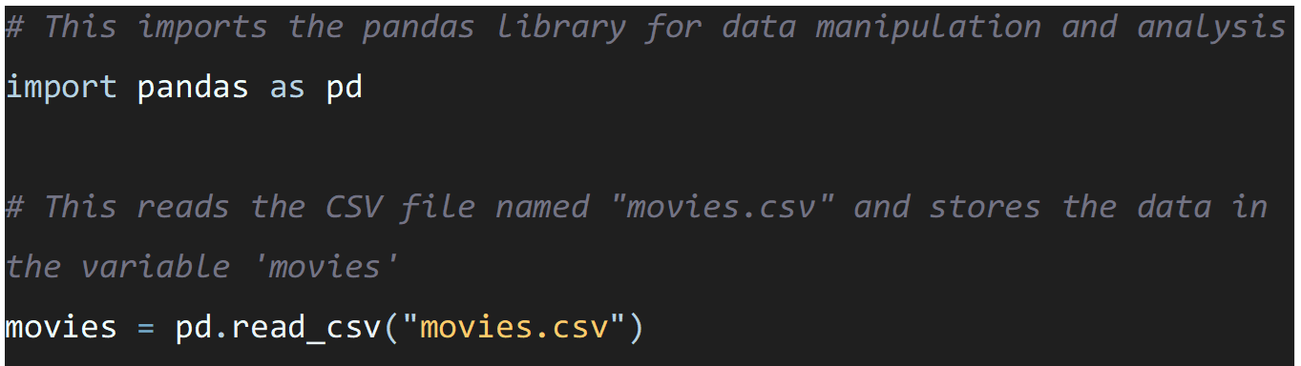

Figure 17 - importing data and libraries

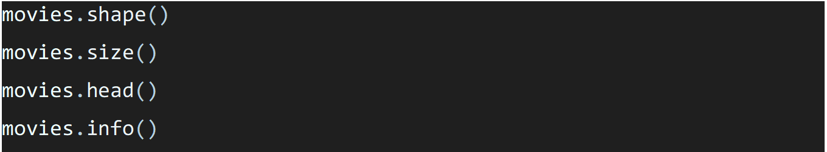

*Figure 18 - Code for exploratory data analysis of the movies dataframe*

`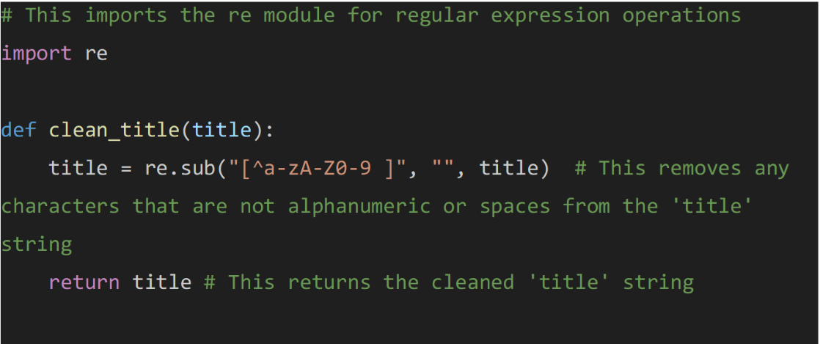

*Figure 19 - Importation of the re library and the clean_title function*

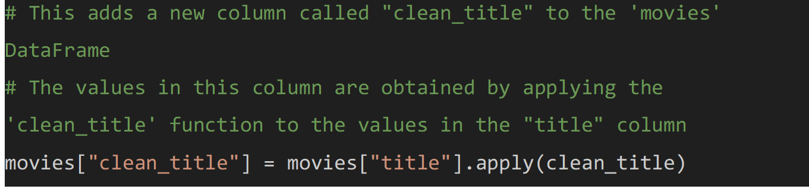

*Figure 20 - creating a new column and storing the cleaned tittle in the movies dataframe*

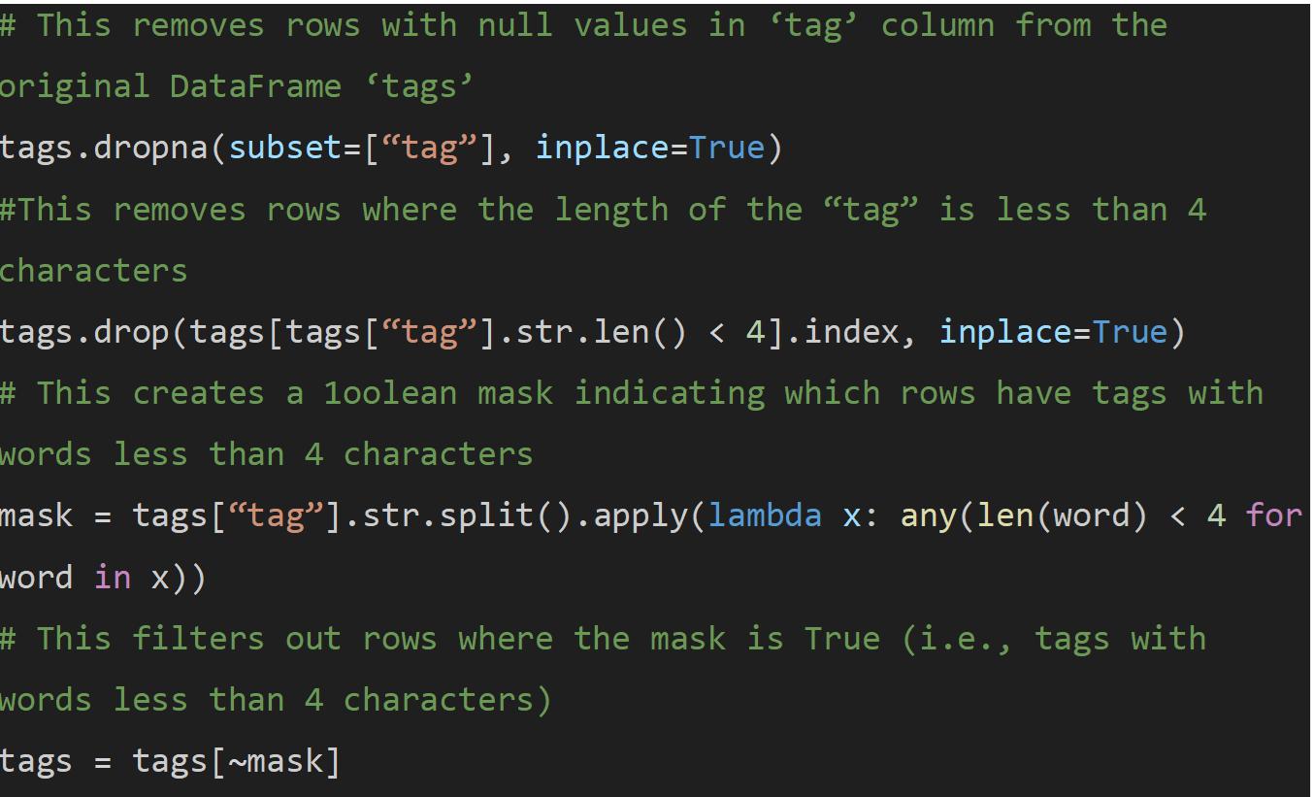

*Figure 21 - Cleaning the tags dataframe*

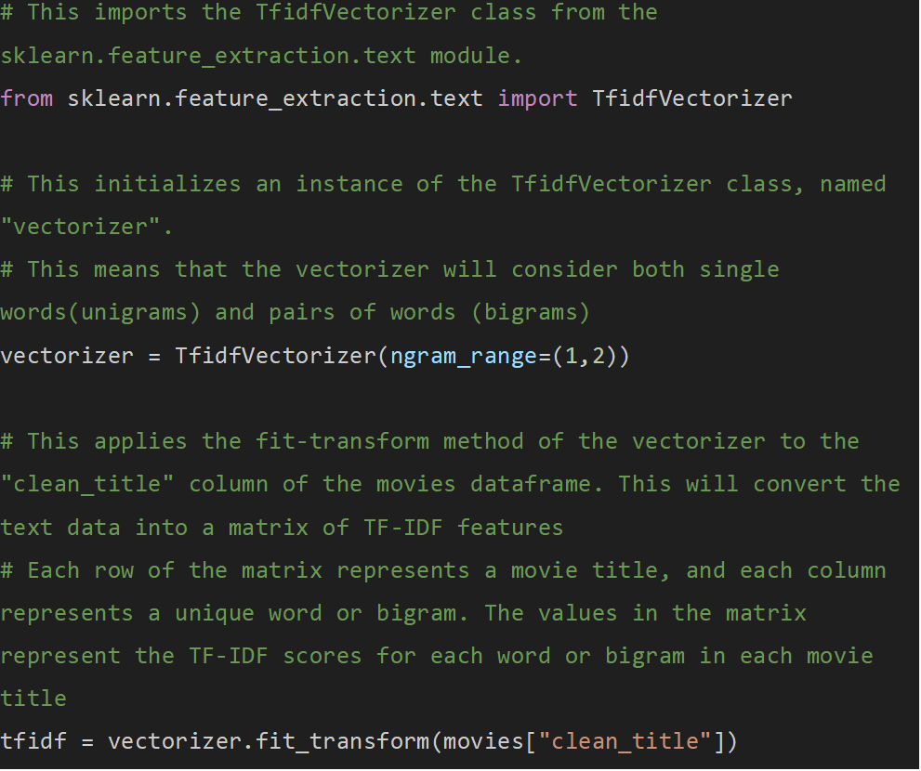

*Figure 22 - the codes for the TF-IDF vectorization*

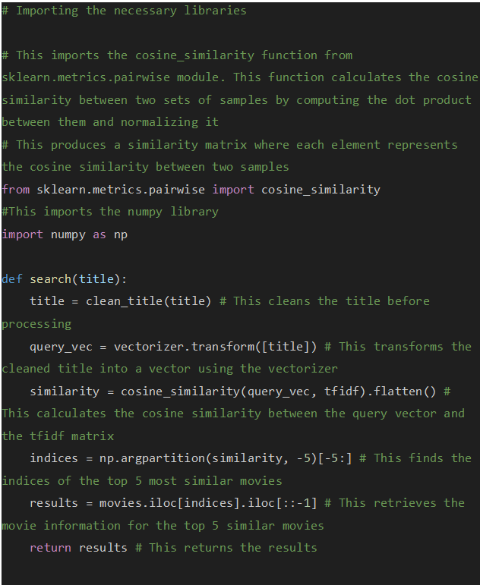

*Figure 23 - search function using cosine similarity*

Figure 24 - Widget enabling User interaction

Figure 25 - The find_similar_movies function

Figure 26 - The creation of the widget enabling the use of the recommendation system